TASK-1
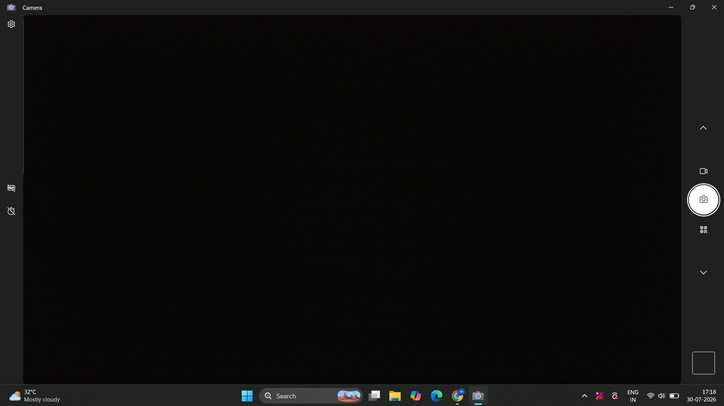

TASK-2
Here is a real-world scenario to make the process feel much less technical, followed by the absolute easiest way to get it done.
The Scenario: The Home Office Upgrade
You just bought a brand new wireless printer to print return shipping labels and your kids' school projects. You’ve taken it out of the box, removed all those annoying pieces of blue tape, and set it on your desk. Your laptop is already connected to your home Wi-Fi.
Here is the easiest, foolproof way to get it running in about 3 minutes:
1.Plug it in and connect to Wi-Fi:Get it online.
Plug the printer into the wall and turn it on. Use the small screen on the printer itself to find your home Wi-Fi network and type in your password, just like you would on a new smartphone.
2.Tell your computer to find it:Let Windows do the work.
On your computer, click the Start button, type "Printers", and hit Enter. Click the button that says Add device (or Add a printer). Your computer will scan the Wi-Fi, spot your new printer, and show its name on the screen. Click on it.
3.Let the driver install automatically:The easiest step.
Sit back for 30 seconds. Windows is smart enough to download the "driver" (the software that helps the computer and printer talk to each other) automatically in the background.
4.Print a test page:The moment of truth.
Once it finishes adding, click on your new printer in that same Settings menu. Click Printer properties (or Manage), and click the big Print Test Page button. If you hear the printer whir to life and spit out a page with the Windows logo on it, you are officially done!

TASK-3
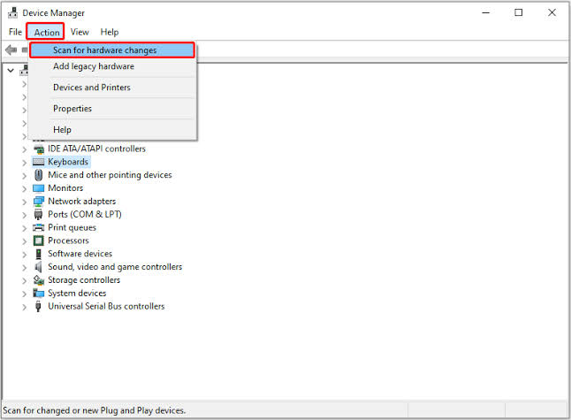
Here is the complete walkthrough to simulate a USB connectivity failure and resolve the 'printer not detected' issue using Windows Device Manager.
1.Simulate the Disconnect:Unplug the USB Cable.
- Unplug the USB cable connecting your printer to the computer.
- Open Device Manager by pressing Win + X and selecting Device Manager (or press Win + R, type devmgmt.msc, and press Enter).
- Expand Print queues or Universal Serial Bus controllers. Notice that the printer has either vanished from the list or displays a yellow exclamation icon (!) indicating a communication error.
2.Reconnect Hardware:Plug the USB Cable Back In.
Plug the USB cable back into a working USB port on your PC. Ensure the printer power is turned on.
3.Scan for Hardware Changes:Use the Action Menu.
- In Device Manager, click Action on the top menu bar.
- Select Scan for hardware changes (or click the monitor icon on the top toolbar).
- Windows will immediately re-examine all hardware ports to detect active Plug-and-Play devices.
4.Verify Detection:Confirm Error Resolution.
Expand Print queues once again. The printer name should reappear with a standard device icon (no yellow exclamation mark), confirming that communication has been fully restored.

TASK-4
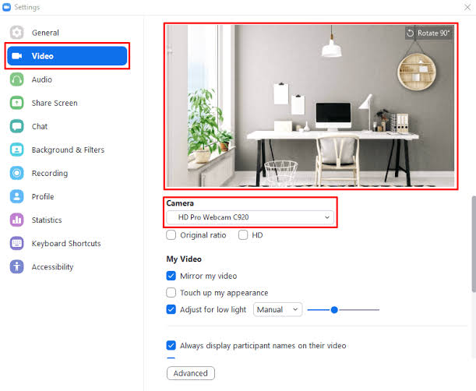
Since the webcam works in the default Windows Camera app, the hardware and device driver are functioning properly. The issue in Zoom is caused by exclusive app access (another app holding the webcam stream), Windows privacy permissions, or selecting the wrong camera device inside Zoom.
Here is the step-by-step resolution:
1.Close the Camera App & Conflicting Programs:Release exclusive camera access.
Most webcams can only stream video to one application at a time. If the default Camera app, Microsoft Teams, Skype, or a web browser tab is actively using the camera, Zoom will show a black screen or an error.
- Close the Camera application completely.
- Open Task Manager (Ctrl + Shift + Esc) and check if any background app (like Teams, Skype, or Discord) is using the camera. End those tasks.
2.Enable Windows Camera Permissions for Desktop Apps:Windows 10 & 11 settings.
Windows privacy settings allow built-in apps (like Camera) to access the webcam while restricting third-party apps like Zoom.
- Press Win + I to open Settings.
- Navigate to Privacy & security > Camera.
- Ensure Camera access and Let apps access your camera are turned ON.
- Scroll down to Let desktop apps access your camera and verify the main toggle is ON and Zoom Meetings is listed as allowed.
3.Select the Physical Webcam in Zoom:Configure input source.
Zoom may be attempting to use a virtual camera (e.g., OBS Virtual Camera, Snap Camera) instead of your physical hardware.
- Open the Zoom app and click your profile icon at the top right, then select Settings (the gear icon).
- Select Video from the left-hand sidebar.
- Under the Camera dropdown menu, select your physical webcam (e.g., Integrated Camera, Logitech HD Webcam, or HD User Facing).
- Verify that the video preview window displays your feed.
4.Test & Confirm Video Functionality:Verify in-meeting controls.
- Uncheck "Turn off my video when joining a meeting" under Zoom Video Settings if you want video to start automatically.
- Go to zoom.us/test to join a test meeting.
- If the camera icon in the bottom-left toolbar has a red diagonal line through it, click Start Video or press Alt + V (Cmd + Shift + V on Mac) to turn on the camera.
Summary Checklist
- Camera App Closed: Yes (releases exclusive hardware lock)
- Windows Privacy Allowed: Yes (grants Zoom permission to use camera hardware)
- Correct Input Selected in Zoom: Yes (switches away from virtual/inactive cameras)

